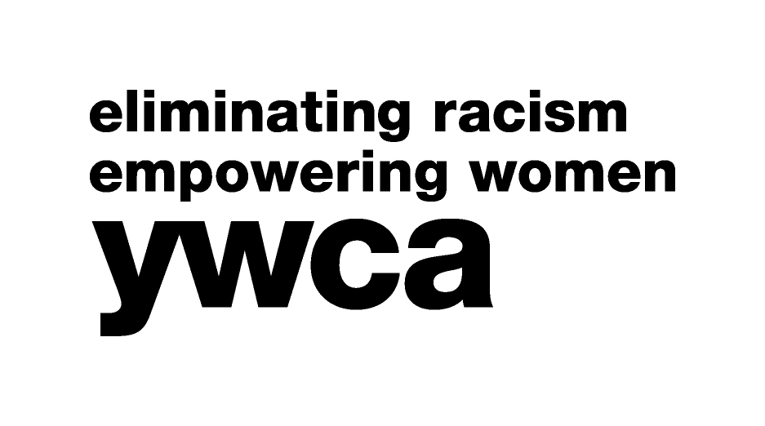 APPLICATION FOR EMPLOYMENT

YWCA KNOXVILLE & the TENNESSEE VALLEY

Oak Ridge Center * Downtown Knoxville * Phyllis Wheatley Center

Date of Application:  Date of Availability:  Position Desired:____________ |  |  | Full Time: |  | Part Time:
PERSONAL:
Name:
Last First Middle Maiden/Other Names Used

Address:
Street City State Zip Code

Telephone:
Home Mobile Social Security Number

E-mail Address_____________________________________________________________________________________________

How did you hear of the position? _______________________________________________________________________________
Do you have a legal right to work in the USA? Yes No
Have you ever been convicted of or plead guilty to a crime other than a minor traffic offense? Yes No
Do we have your permission to check your criminal record? Yes No
Has there ever been a “founded” allegation of child abuse against you? Yes_______ No _______
Has there ever been a “founded” allegation of dependent adult abuse against you? Yes ______ No _______
EMPLOYMENT EXPERIENCE:
Dates Employed:  From: To: |  | Position Held: | Rate of Pay: | Reason for Leaving:
Employer’s Name & Address: |  |  | Supervisor’s Name/Address/Phone:
Description of Duties:

Dates Employed:  From: To: |  | Position Held: | Rate of Pay: | Reason for Leaving:
Employer’s Name & Address: |  |  | Supervisor’s Name/Address/Phone:
Description of Duties:

Dates Employed:  From: To: |  | Position Held: | Rate of Pay: | Reason for Leaving:
Employer’s Name & Address: |  |  | Supervisor’s Name/Address/Phone:
Description of Duties:

EDUCATION:

Indicate Most Recent Institution First

Dates Attended:  From: To: | Name/Address of Institution: |  |  |  |  | Did you Graduate? Yes: No:  Degree Earned:
Dates Attended:  From: To: | Name/Address of Institution: |  |  |  |  | Did you Graduate? Yes: No:  Degree Earned:

ACTIVITIES:
Dates of Service:  From: To: | Name/Address of Organization: | Type of Service Performed
Dates of Service:  From: To: | Name/Address of Organization: | Type of Service Performed
REFERENCES:
Indicate Individuals Who Have a Definite Knowledge of You and/or Your Qualifications

Name & Relationship: | Mailing Address: | Telephone Number | Number of Years Known:
Name & Relationship: | Mailing Address: | Telephone Number | Number of Years Known:
Name & Relationship: | Mailing Address: | Telephone Number | Number of Years Known:
Indicate by Checking Your Permission to Contact the Following:

Present Supervisor: Former Supervisor: References Listed Above:

My Signature indicates that the Previous Information is Complete and Correct to the Best of my Knowledge. I Understand That, If Employed, Any Misstatement or Omission of Facts May Result in My Dismissal. It Is Also My Understanding That All Employees Are Subject To A Criminal Background Check.

Signature Date

The YWCA of Knoxville is an Equal Opportunity Employer, and, as such, does not discriminate on the grounds of disability, age, race, color, religion, sex, national origin, or any other classification protected by constitutional or statutory law.

As an Applicant for a Position in the YWCA, You May Help Us Monitor Internal Accountability to Our Affirmative Action Program.
*Please Check the Appropriate Space Listed Below:

American Indian African American Hispanic Asian Caucasian Other

*Please Note That You Are Not Required to do so as a Part of Your Application and That This Portion is Strictly Voluntary.

Our Mission

The YWCA Knoxville is dedicated to
eliminating racism, empowering women and
promoting peace, justice, freedom
and dignity for all.

